NOTES ON INSTALLING THE RGR SP250 TELESCOPIC SHOCK ABSORBER CONVERSION

CAUTION: Before commencing the installation, ensure the rear road springs are in good condition and replace any worn or distorted parts. It is important that the rear springs are operating correctly otherwise this may please unnecessary stress on the new dampers. Support the chassis securely on stands. Under no circumstances should a car be worked on if it is only supported with a jack or inadequate stands.

- Remove both rear wheels and then remove the lever arm shock absorbers complete with their link arms. Remove the lower spring plate by undoing the 4 nuts on the U bolts on either side.
- Remove the retaining set screws from both bump stop hoops. Fit the new polyurethane bump cushions using the cable ties supplied. See picture 1.
- Slide in the left and right hand fabricated brackets behind the existing shock absorber mounting plate on the chassis. See picture 2. If required, use the thick & thin shims provided in any combination to achieve the best fit of the cross bar which can be trial fitted at this point. Fit the original shock absorber mounting bolts using the new Nyloc nuts supplied but leave the nuts loose and do not tighten at this stage.
- Next fit the new bump stop hoops using 3/8” UNF x 1¼” set screws at the front chassis top mounting point and 3/8” UNF x ¾’ set screws at the rear mounting point. All 4 set screws should be fitted with plain and spring washers. Note the bump stop hoop front mounting should be sandwiched between the fabricated bracket and the chassis on both sides. Again, do not fully tighten.
- Install the cross bar with the end tabs pointing downwards and fit in front of the triangulated plates on the left and right hand fabricated brackets fitted in step 3. Retain the cross bar with four 3/8” UNF x 1¼ ” set screws with flat and spring washers. See pictures 1 & 2.
- Now tighten all set screws to secure both fabricated brackets to the chassis, the cross bar to the brackets and the bump stop hoops to the chassis.
- Fit bottom plates to the underside of springs using the 8 new Nyloc nuts supplied. See picture 3. Ensure the U bolts are drawn up evenly with approximately the same length of thread showing on each bolt.
- Fit shock absorbers using 3/8” UNF bolts, flat washers and Nyloc nuts. 2” bolts are used at the top with 4 ” bolts at the bottom. Ensure the shock absorber adjusters are at the bottom and face outwards. If shields are fitted to the rear brakes, remove the knurled adjuster wheel to obviate any clearance issues. Note the spigot is slotted and can be adjusted using a screwdriver if the wheel has been removed. Turn the spigot fully anti-clockwise to select its “softest” setting. Check there is a minimum of 5mm clearance between the shock absorber and the rear springs. Depending on the tolerances on your car, it may be necessary to fit the spacers supplied to adjust the gap at the bottom mounting. See picture 4.
- Refit the rear wheels and road test the car. If the rear end feels too soft, turn the spigot clockwise by the same amount on each shock absorber until you reach a ride setting that suits you.

PARTS SUPPLIED

1 off Cross Bar | LH/RH Fabricated Brackets | 2 off Lower Spring Brackets | 2 off Shock Absorbers | 2 off Bump Stop Hoops
4 off 3/8 x 1 ¼ ” UNF set screws | 4 off 7/16” UNF Nyloc nuts | 8 off 7/16” UNF Nyloc nuts | 2 off 3/8”x 2” UNF bolts | 2 off 3/8”x 1 ¼ “ UNF set screws
4 off 3/8” flat washers | 2 off thin shims  2 off thick shims |  | 2 off 3/8”x 4” UNF bolts | 2 off 3/8”x ¾ ” UNF set screws
4 off 3/8” spring washers |  |  | 4 off 3/8” UNF Nyloc nuts | 4 off 3/8” flat washers
 |  |  | 8 off 3/8” flat washers | 4 off 3/8” spring washers
 |  |  | 2 off 3/8” spacers | 2 off p/u bump cushions
 |  |  |  | 4 off cable ties

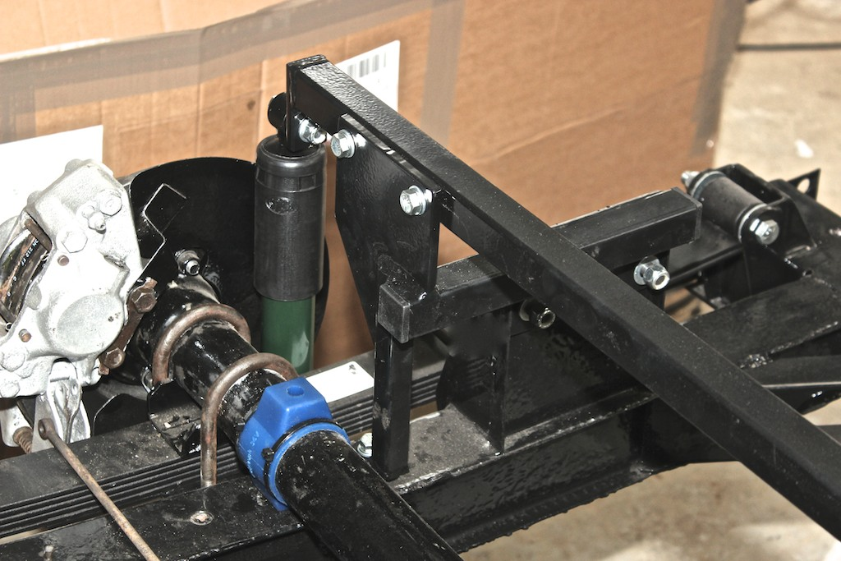
Picture 1. Note: The bump stop hoop has been omitted for clarity. Also see that the new bump stop cushion (blue) is now mounted on the axle tube rather than being moulded in the top of the hoop itself.

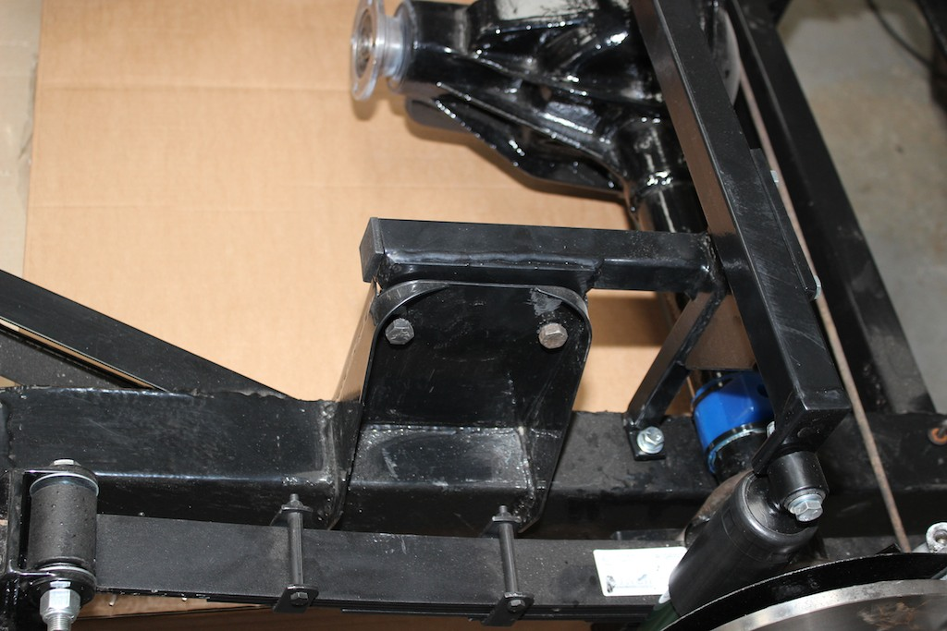

Picture 2. Again, the bump stop hoop is omitted for clarity. If required, the thick and thin shims can be used in any combination between the fabricated bracket and the original shock absorber mounting bracket to achieve the best fit of the cross bar.

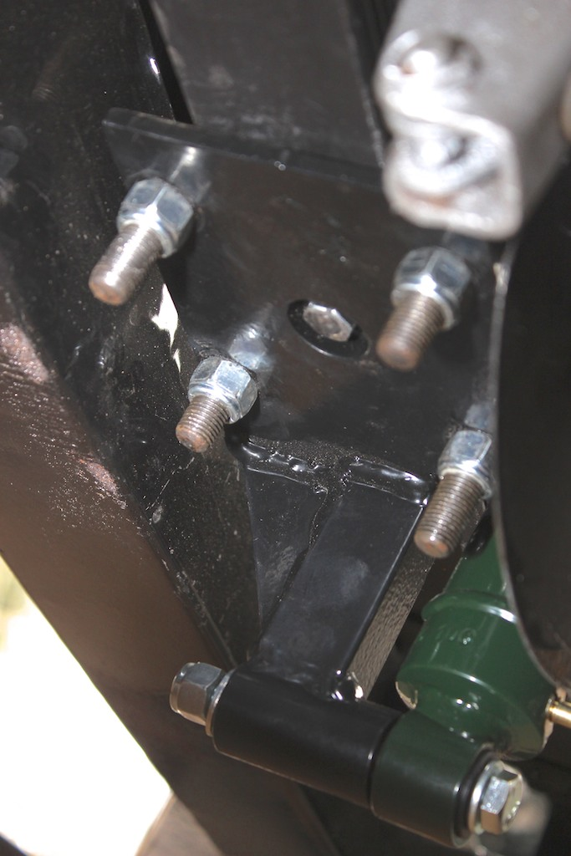

Picture 3. Shows bottom plate on rear spring

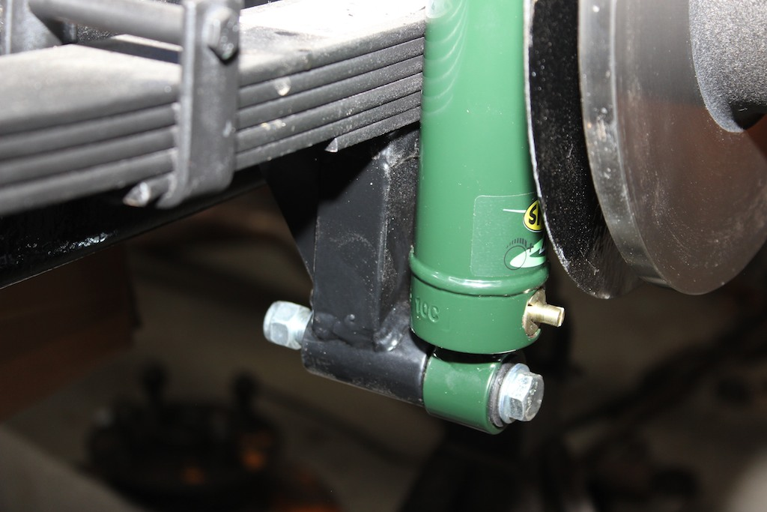

Picture 4. Shows adjuster spigot with the knurled adjuster wheel removed. The spacer supplied can be fitted between the shock absorber and the spring plate if it is necessary to increase clearance between the spring and the shock absorber casing.

